**M1 – Recommend methods to promote an e-commerce system**

**Introduction**

In this report, I will recommend methods to promote an e-commerce system. I will explain each one with a summary of why I recommend it.

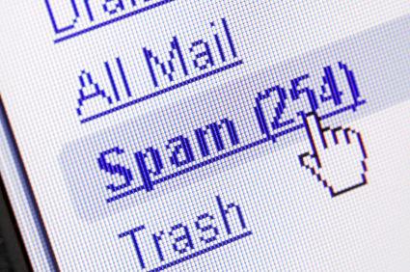**SPAM Email**

Email spamming is also known as junk mail, an email that promotes malware. It is a ‘SPAM’ email, because the email is always sent. They never stop. However, if you click on it, you may get malware on your system. It is advised for the user to delete all the junk mail. Anyone can send junk mail. This is a good way to promote your website, because if the user were to click on Tick Tock, he or she would view it.

**Paying for prominence in search result listing**

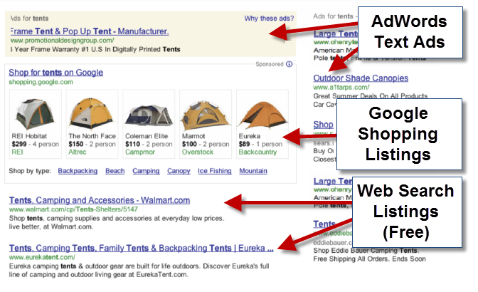One of the main ways an e-commerce can promote their website is by the ranking of the search engine. This is done by paying the search engine to put their website at the top. Some new companies, that have new websites, may be so far down that the user cannot find the information on the website they are looking for. It does not happen straight away. It may take months, or even years, for it to be at the top. It works as a bid. Obviously, for different search engines, it works differently. The bid starts at £0.04 and the highest bidder gets the top rank. They are different ways by using other search engines to promote the website, and this way, it takes longer as well. The picture below shows how the listing works. Tick Tock can use this suggestion and if someone were to type in Tick Tock, there website would appear on Google Search engine; but only if they win the bid.

**Newsgroups and forums**

Newsgroups and forums are a very good way to promote anyone’s websites. Newsgroups are similar to an email account, but the only difference is that everyone can see it. For example, if I were to send a message, on a newsgroup, some people of the community would be able to see it. This is a good way to promote Tick Tock’s website to the community, and the world. Forums is similar too. This is a discussion that most people have with each other. If someone promotes Tick Tock’s website, more people would know it.

**Banners and pop ups**

Banners and pop ups is a form of advertising towards customers around the world. This is done by the banner being linked with the website. Once the banners are created and put on the website, the company can gain more customers. It is the most effective way to promote any website. What the user needs to do is click on the website banner, and it would direct them to the promoting website.

This is a classic example of a pop-up. The user has a choice to click on it, or close it. Banners is within the website. Pop ups just simply pops up on the page.

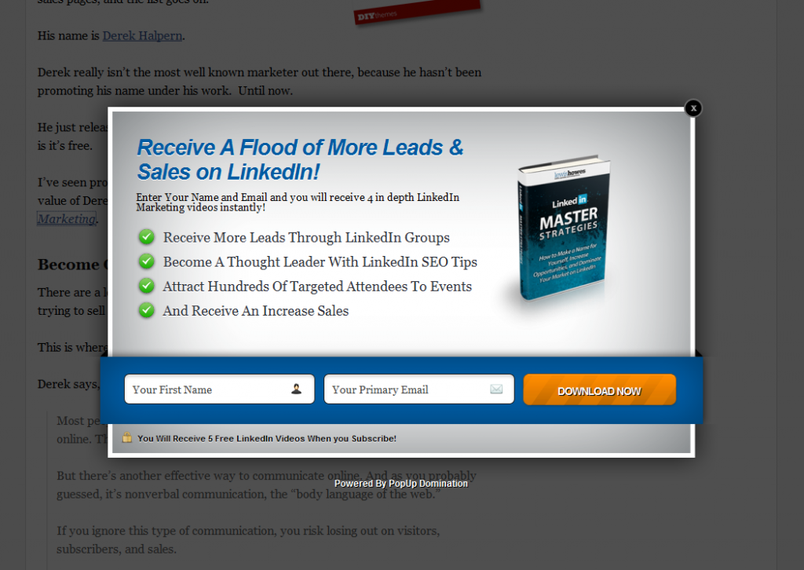

**Site name**

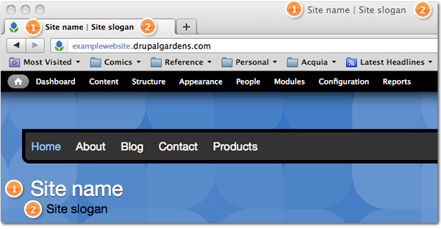Having a simple and unique site name would encourage customers to use the site more. It has to be short and snappy. For example, Tick Tock. This is very short and memorable. It is was to be longer, the customer would not be able to spell it. Some mistakes in it would enable the user not to find the information they were hoping to. All the top brands have it memorable. If Tick Tock were to be Click and Brick, they can hand out leaflets encouraging customers to use their website too.

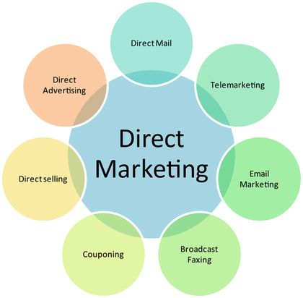**Direct marketing**

This is another effective way to promote any businesses’ website. This is done by directly communicating with the customers. This could be done by calling, texting, emailing, ads, and many more. For example, if Tick Tock would want to communicate with their customers, they would email them. One reason would be that they would want to do a survey. If 10 out of 20 respond, it is good way to improve the website. Thirty-two percent of customers would prefer to be contacting through Direct Marketing.

**Effective use of search engines using Meta tags & ‘spiders’**

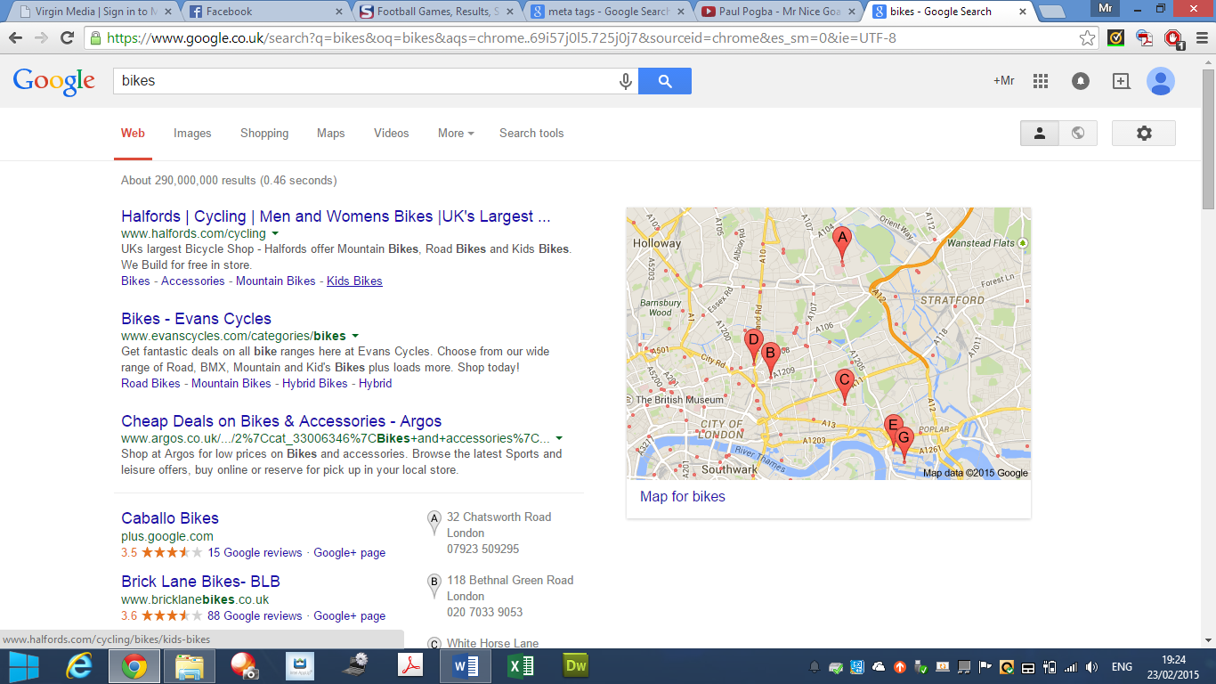Meta tagging is elements within the HTML document that shows information of what is about the web page, which created the page, and which keywords represent the page’s content. It shows varied of content within the tags. This is an effective way to describe what the website is all about. If I were to type in bikes, the search engine would give me a great deal of information for each of the content I am looking for. This image shows us that behind each of the website; it shows what bike I want. It promotes the websites by giving it a brief introduction to the customer.

**Ensuring an effective user interface**

Ensuring an effective user interface allows customers to work around the website easily. If the e-commerce does not look good, it would discourage the customer to not use the website again. The website needs to look professional and easy to use. A person that is not use to using technology would be able to use it. It needs to work simply to gain more customers. A clever technique to use is to zoom the images in within the website. For example, if a person at Tick Tock cannot see properly, the user would be able to zoom it in to have a better look at the product. Small features like these enables more customers using the website more.

**Summary**

I recommend promoting your website by paying in order to be the highest rank, especially for Google. Google search engine is very popular and Tick Tock would receive many customers by this. I also would recommend Direct Marketing. This is because the company talks to the customers directly. They stay in touch with the local customers. The one that I do not recommend is SPAM email. Most people are recommended to delete it because it is not trusted. Not many people use email, and when they do, SPAM email is always deleted y the users.

**Reference**

* <http://searchengineland.com/figz/wp-content/seloads/2012/05/shopping-after.png>
* <http://thewebalyst.com/wp-content/uploads/2011/07/spam-folder.jpg>
* <http://techzulu.com/wp-content/uploads/2011/11/pop-up-domination.png>
* <http://www.marketstormglobal.com/wp-content/uploads/2014/04/direct-marketing-business.jpg>
* <http://byte-technology.com/blog/wp-content/uploads/2013/10/user-interface.jpg>